
Island Stands: Space Only and Shell Scheme

Island stands are an ideal way to showcase your business as they can be seen and accessed by delegates from all sides.
Rules when designing a layout for an island space:
- You must not create a solid wall on your stand, focus on having a central display point or column in the middle of the space
  - Do not put pull up or pop up banners along the perimeter of your stand as this creates a barrier and blocks you, and other exhibitors around you, off from the walk ways
- Please do not exceed the 2.5m height limit unless you have confirmed your plans with the Operations Manager – Elizabeth Tomkinson (eli@revolution-event.com)
- If you plan to build anything bespoke within your space please submit full dimensional stand design drawings.

Shell Scheme Island Site:
If you have booked a fully inclusive shell scheme island stand, be aware this stand will be open on all sides and will have no walling. An example of what the shell scheme will look like can be seen below:
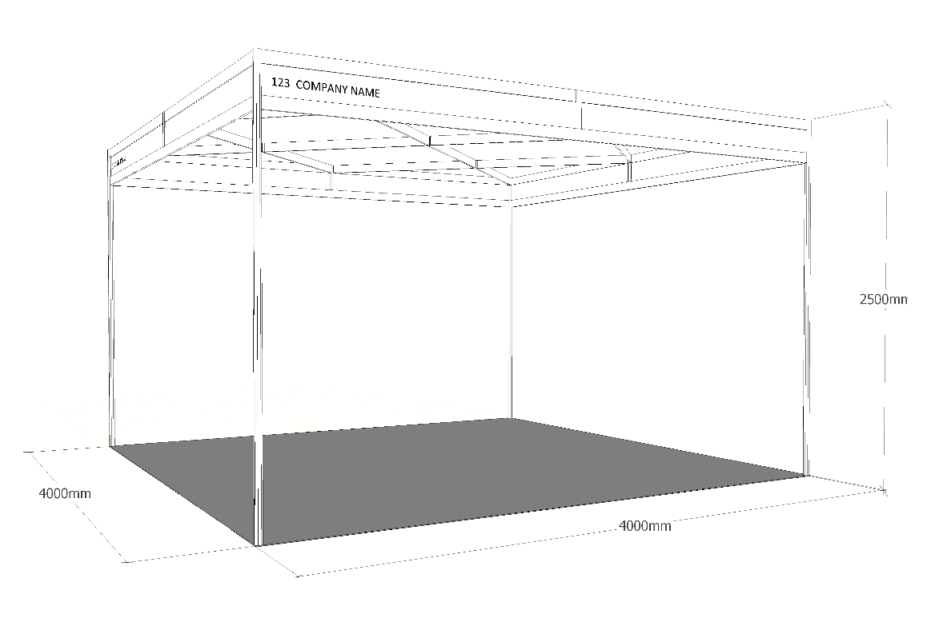

NB: This is a representation ONLY and is not specific to the stand you have booked

Space Only Island Site:
Space only stands do not come with any power, furniture or shell scheme. They consist of a designated space on the floor for you to build a bespoke display.
All space only stands must submit a full plan for approval, accompanied by a Risk Assessment and Method Statement covering the build-up and breakdown activities.
The organiser have the right to refuse a design if it may effect surrounding space, for example blocking sightlines, or exceeding 2.5m in height.
Dependant on your design you may be asked to install your space only stand up to two days prior to the show opening. This is to allow you to get the equipment you may need into the hall as easily as possible.
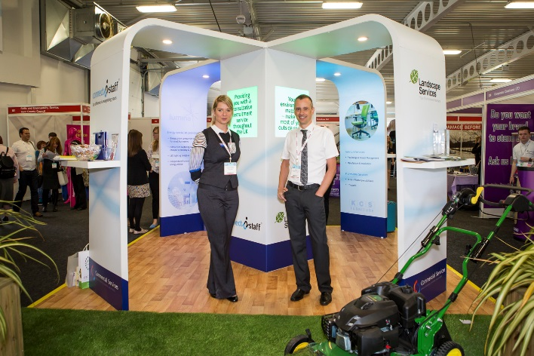



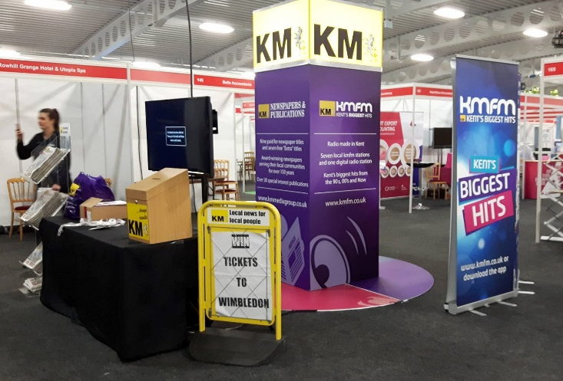
Above: Bespoke design Space Only Island site.
Exhibitor provided flooring and bespoke build.

Below: Space Only Island site using provided venue carpet.
Above: Bespoke design Shell Scheme Island site.
Stand built within the provided facia and ceiling grid.

Below: Space Only Island site using provided venue carpet.

